 

**Placement Empowerment Program**

***Cloud Computing and DevOps Centre***

**DAY 2 TASK**:

Automate file copying with script: Create script to copy file from one folder to another.

**NAME:** NITHYASRI S.K

**DEPARTMENT:** ADS

**INTRODUCTION AND OVERVIEW:**

As day 2 task, we are going to create a script to copy file from one folder to another file. This POC will demonstrate how to copy file from source to destination automatically using a simple and effective method.

This process ensures that all the contents and files are copied or transferred efficiently. The script can be of any type such as html, python etc.

**IMPORTANCE :**

1.Time saving – This process eliminates manual intervention and saves a lot of time.

2. Error reduction – Reduces human error.

3.Useful in various scenarios – Helps to maintain backups and secured structure for file storage.

**EXPECTED OUTCOME:**

From this POC we will learn how to copy a file from one folder to another and understand how to use Task Scheduler to automate repetitive tasks in Windows.

**STEP BY STEP OVERVIEW :**

STEP1:

* Create two folders and name them as source and destination.
* Insert any kind of file in the folder Source.



STEP 2:

Open a notepad and type the following code and save it in the desktop with .bat extension (eg: index.bat)

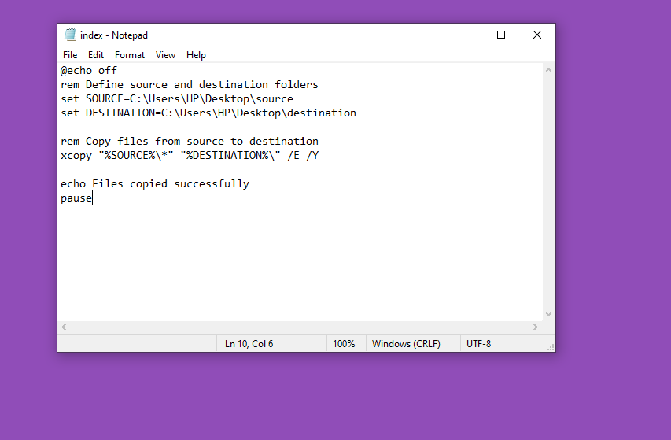

STEP 3:

* Press **WIN+R** and type taskschd.msc in run box.
* Enter OK .

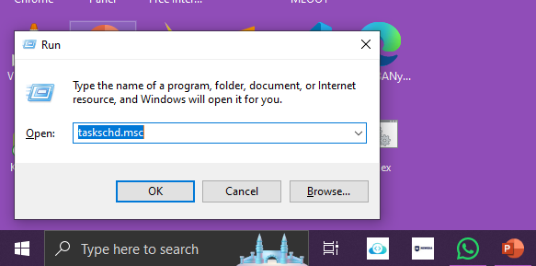

STEP 4:

In Task Scheduler window click “Create Basic Task”.

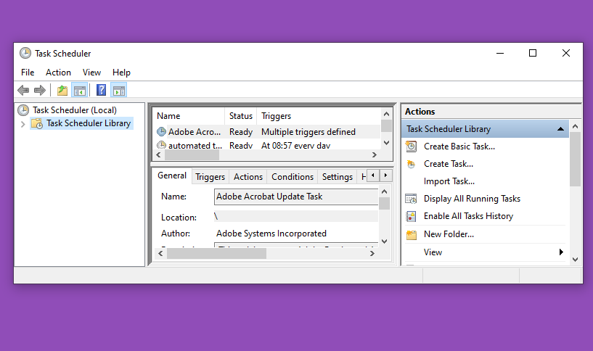

STEP 5:

* Create a task name (Automate File Copying) and add description if needed.
* 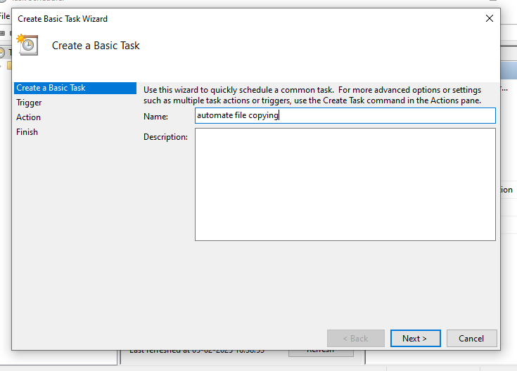Set trigger as Daily and schedule time.

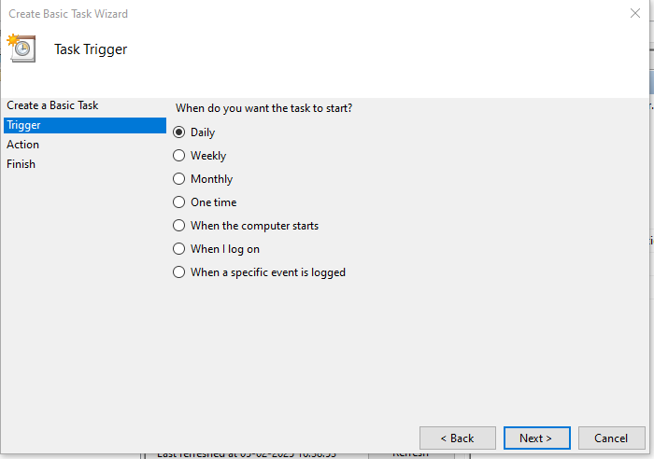

* Select Start a program.

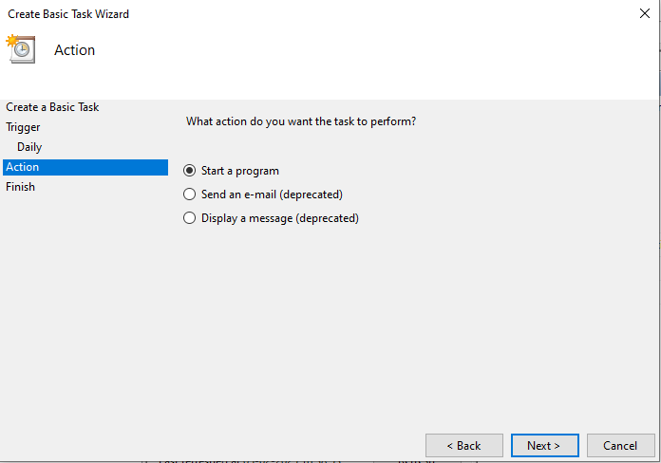

* Browse the file and click Next.

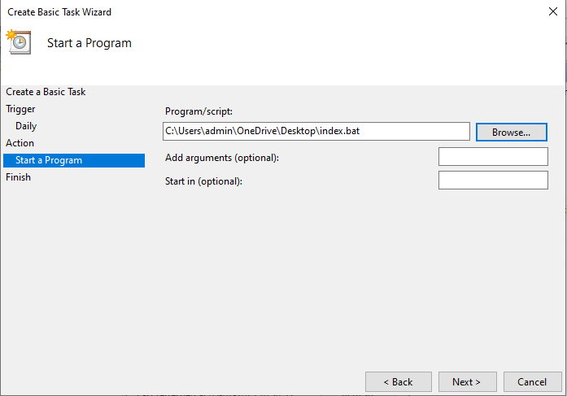

* Review and finish.

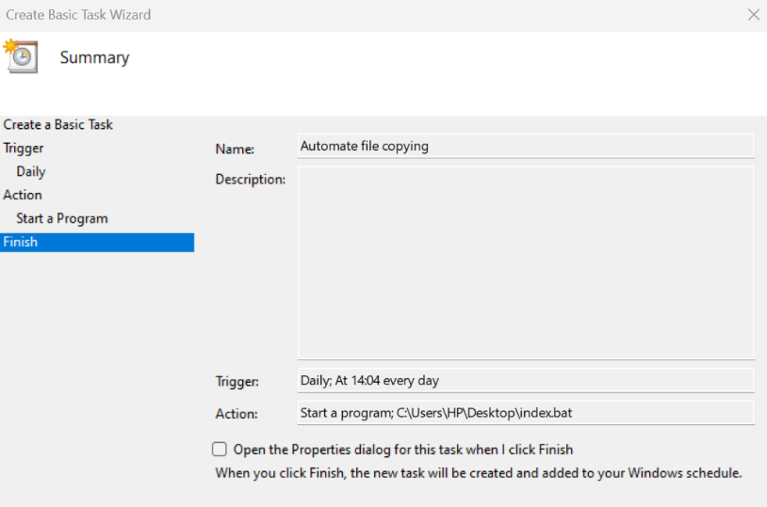

This will manually trigger the task

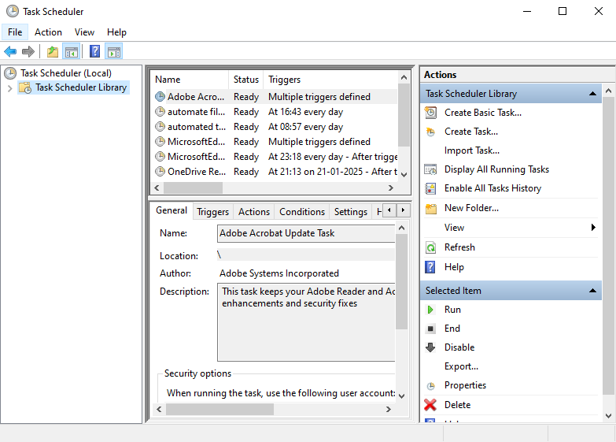

STEP 6:

* Right click the task and set Run.

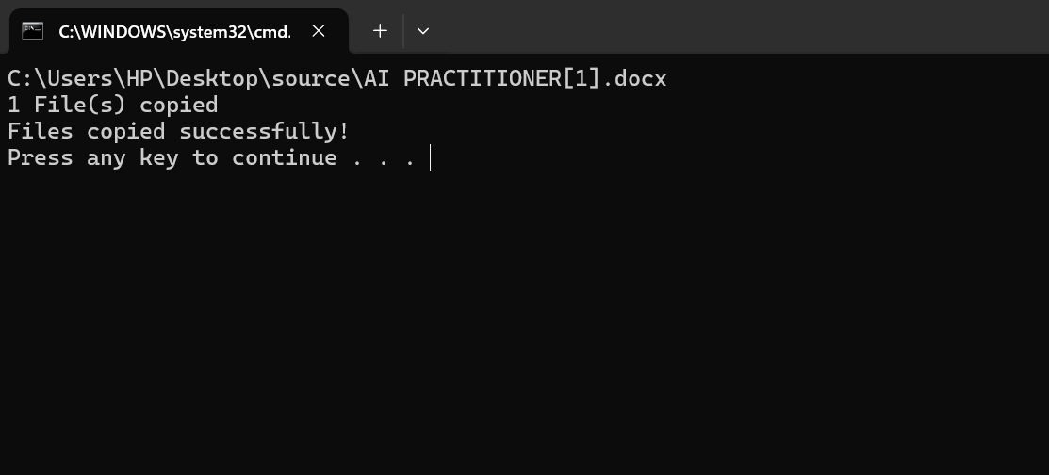

Make sure that the task has been successfully copied by viewing the destination folder.

